**1.**When we need to compress archive files or decompress archive files.

Screen shot:

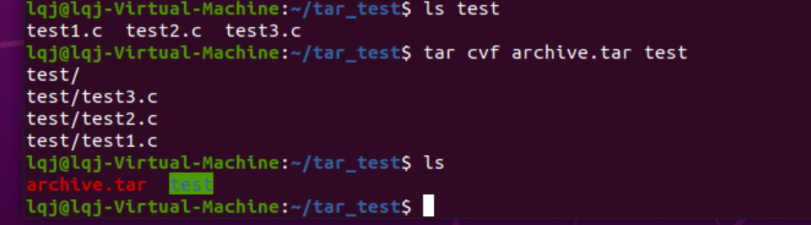

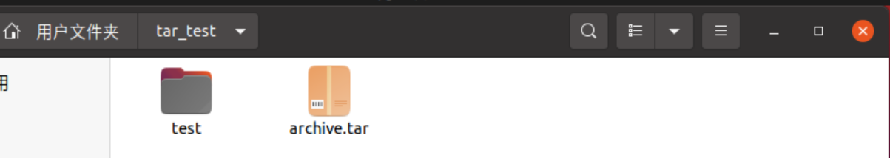

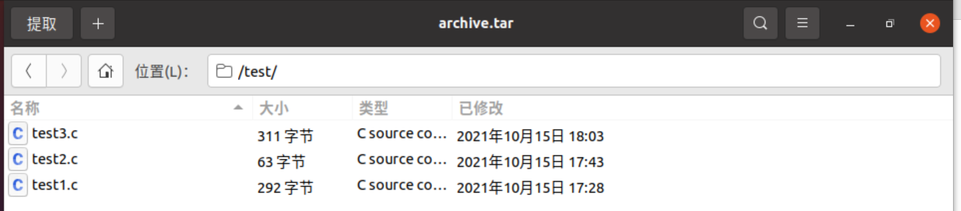

**2.Sed**: stream editor

The sed editor can process the data in the data stream according to the command. Read data from data one row at a time.

**Gawp**: Interactive editor

The main use of gawk is in program scripts, so that we can write scripts to read the data of text lines.

**3.**

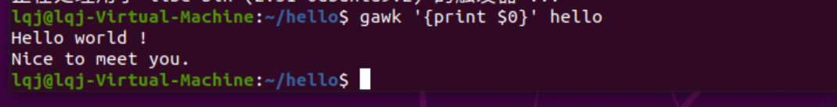

**4.**



**5.** **Su**: Change to another user's identity.

**6. gzip** -c

**7.** Symbolic links can span filesystems and can even point to files in remote filesystems, while hard link cannot.